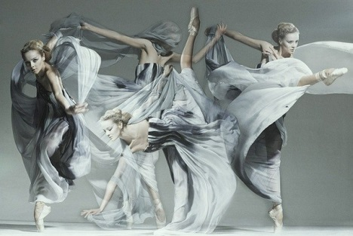 Dancing Show: “the Magic of the Dance”
The dance is your pulse, your heartbeat, your breath. This is the rhythm of your life. It's the expression of time and movement, of happiness, joy, sadness and envy. (Jacques d’ Amboise)

Compere I: Dear ladies and gentlemen! We are glad to see you at our Dancing Show! Today you’ll have a close touch to different types of dances. You’ll be involved into the world of plastic arts and motion, gracefulness and inexpressible feelings. It is the WORLD of DANCE, the world of expression of the soul, feelings and emotions!
(song “Feelings”)
Compere II: By the way, what is a dance for you?
Compere I: Oh, it’s everything for me! It’s my life! It’s my soul! It’s my friends with whom I spend the greater part of my everyday life! And, of course, it’s a very hard work! And what about you?
Compere II: Just the same things! I can’t imagine my life without dancing.
Compere I: And do you remember those days when you started dancing and when you came to this school holding your mum by the hand?
Compere II: Of course, I do! I was only 5 years old!
Compere I: And how did you feel yourself then?
Compere II: Oh, I don’t remember exactly but I think I was embarrassed!
Compere I: And how do you feel yourself now, after 10 years of dancing?
Compere II: Frankly speaking, not bad! And I’m not embarrassed anymore!
Compere I: Pleased to hear that! But let’s get down to business. (to the audience): Today you’ll be represented several dances. And the first dance which will be represented to you is the hustle.

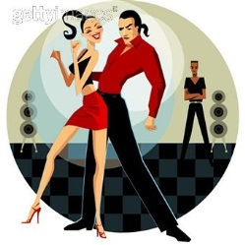 Hustle 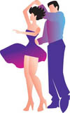

"Things may come to those who wait, but only things left by those who hustle." Abraham Lincoln

Compere II: Hustle? What kind of dance is it?
Compere I: It’s a kind of disco dance which has some features in common with Swing dance. And its history is rather interesting.
Compere II: What’s interesting about it?
Compere I: You know, in the 70s discotheques became a popular form of entertainment in Europe and America.
Compere II: Oh, my mum told me about this! She used to go to discotheques at that time. By the way, she’s a good dancer!
Compere I: Good for her! So once at one of the discotheques a new “touch dance”, without a name, was being exhibited by a woman. It was a simple 6-count step with a very basic form, including inside and outside single turns. The young men of the club took notice, and became interested in this new “touch dance” as it was a return to romance and simply, the way to meet a woman!
Compere II: Was it the birth of what we now call hustle?
Compere I: Exactly!
Compere II: How romantic!
Compere I: Yes, I agree with you.
Compere II: Was it changed during its history?
Compere I: Of, course! The dance began to gain popularity. More and more people began to participate and, of course, it began to evolve. Acrobatic and adagio movements were introduced into the dance. It became faster and more exciting. In order to move quickly into and out of the tricks which were becoming so popular in the contests, “&4-5-6” became “&1-2-3”. This was the birth of Hustle as it is counted today.
Compere II: Did the dance take from other styles?
Compere I: Oh, yes! During its history hustle borrowed from other dance styles. These included Smooth Ballroom, from which it took traveling movements and pivots, as well as other partner dance forms such as Swing, and the Latin rhythm dances. There are a lot of variations of this dance, among them: «Western Hustle», «Continental-American Hustle», «L.A. Hustle», «Latin Hustle», «New York Hustle», «Street Hustle», «Double Hustle», «Tango Hustle», «Line Hustle», «Rope Hustle», «Swing Hustle».
Compere II: Thank you for an interesting story! I think it’s high time to watch the dance.
I and II compere (together): Meet hustle dancers!!!
(Hustle dance)
Compere I: Thank you very much! It was great!

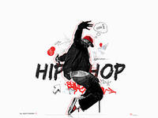 Hip-hop 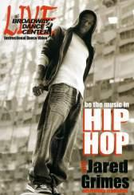
Compere II: And now you’ll see the second dance. It is one of the most popular dances among the young people now. How do you think what it is?
Compere I: I don’t know exactly. May be I’ll ask the audience. (to the audience): What is the most popular dance now?
Pupil: I think, it’s hip-hop.
Compere II: Exactly! It’s hip-hop. What do you know about this dance?
Compere I: I’m afraid, I don’t know much about it but what I know is that hip-hop has the beat which makes you want to get up and dance!
Compere II: You are right. Hip-hop is a good choice for those who like movement and rhythm, positive energy and improvisation. Do you remember Beyons in her track “Run the World”? It is a great hit in the world of dance and music!
Compere I: Yes, I like it very much.
Compere II: The first mention of hip hop dance also dates back to the 70s. At first, it was most popular among African Americans and Latin Americans, but then it became popular in other countries too. Ukraine was not an exception.
Today, hip-hop has taken its place alongside ballet, tap, jazz and ballroom dancing and includes such features as breaking, popping, locking, gliding, ticking, vibrating and krumping.
Compere I: Oh, dear! So many new terms! I agree that it’s better to see once than to hear one hundred times! That’s why, let’s see the dance. Meet hip-hopers!!!
(Hip-Hop dance)
Compere II: Thank you very much! You were superb!
Compere I: We want to tell you about one more modern style of dance which is unknown for the part of us. This is the street jazz.
street jazz 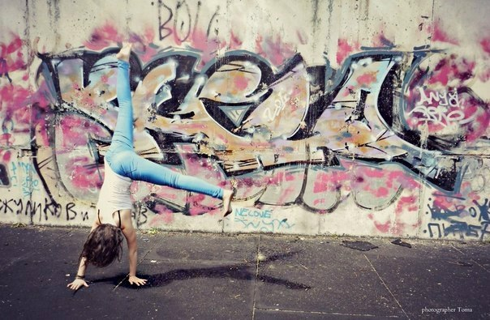
Compere II: So, what exactly is the street jazz?
Compere I: Street jazz dance evolved from informal dancing often done in informal settings in nightclubs, schools and on the street. Street jazz dance was inspired by traditional dance performed outside of professional studios.
Compere II: Jazz dance, modern hip hop and funk make up street jazz dance. In fact, the hip hop and funk dance styles that appeared on dance scenes in the 1970s inspired the development of today's street jazz dance.
Compere I: Considered by some as a sub-dance style or variation of hip hop, street jazz dance has several forms: hip hop, jazz dance, broadway dance, breakdancing and contemporary dance.
Compere II: What are the features of this dance?
Compere I: Urban styles, such as elements of breakdance, tecktoniks, and other dance forms, are featured in street jazz dance.
Compere II: How can we identify this dance?
Compere I: Street jazz dance can be identified by performers' fast and intricate footwork, refined spins and acrobatic flips and moves. Inspired by modern hip hop, street jazz dance resembles this original street style.
Compere II: Now let’s see the street jazz dance!
(Street Jazz dance)
Compere I: Thank you for the dance! It was amazing!
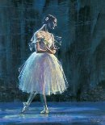 BALLET 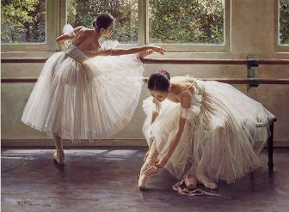
Compere II: So after presenting modern dances it will be interesting to draw your attention to classical dance.

Compere I: Are you going to speak about the ballet?
Compere II: Yes, you are right, it’s the ballet. The ballet can tell a story, express an emotion, reflect a piece of music or simply show a choreographed series of movements.

A well-executed ballet transports the audience into a fantasy world where dancers defy gravity as they leap, maintain balance during dizzying spins, glide along their tiptoes and rise into the air as if light as a feather. A fine ballet is graceful and natural.

Compere I: Yes, I agree that it is this illusory fantasy world that has enthralled audiences for centuries.
Compere II: Though the ballet is often considered French, at first it was danced in Italy. Originally the term was applied to Renaissance dances of the Italian court. Men dressed as women danced female parts.

Compere I: Wow! How interesting to see men dancing female parts! As far as I know, now the ballet has different forms. Some perform modern dances choreographed to very modern music, but many others still prefer a traditional type of footwork in performances like “Swan Lake.”

Compere II: The ballet interprets music through a variety of accepted movements. More modern forms may incorporate elements from other dance traditions, but traditionalists see this as a denigration of this centuries old art form.

Compere I: Did you want to be a ballerina when you were a little girl?
Compere II: Yes, of course. Who didn’t?

Compere I: Really so, but it’s very hard to dance the ballet. Women must be very thin, and appear almost girlish in figure, provoking an epidemic of anorexia and bulimia among female dancers.

Compere II: Oh! I don’t want anybody to sacrifice! But we can start a little ballet studio at our school.

Compere I: This is good idea! Let’s imagine how it could be!

(Ballet dance)

Compere II: Oh, it was magnificent! You were real ballet dancers!

Compere II: Thank you to all participants for presenting the most popular dances. And now we’ll have a quiz “WHO KNOWS DANCES BETTER”? You’ll see different kinds of dances on the screen and your task is to give their names. If you are right, you’ll get a point. The more points you’ll get the better for you. Are you ready? Let’s start. (a quiz)

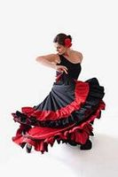
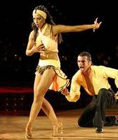
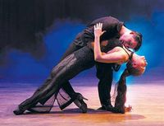

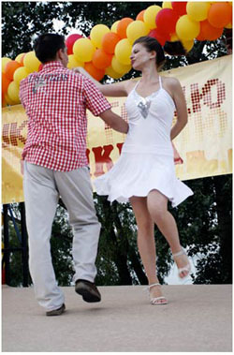
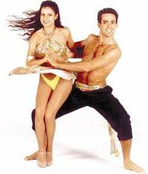

Compere I: Let’s count the points. Who’s got most of them? Our best congratulations!
Compere II: Unfortunately, our dance show is approaching its end. To finish it let’s see some interesting videos which prove that a dance is available to people of different age. (video clips)

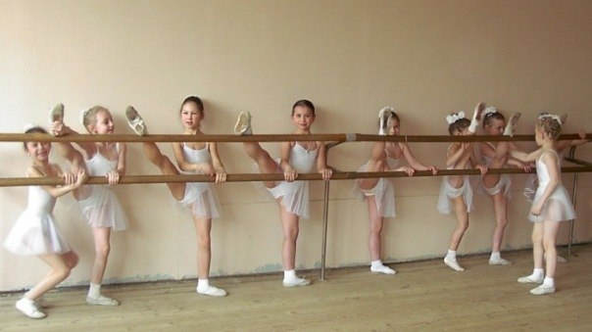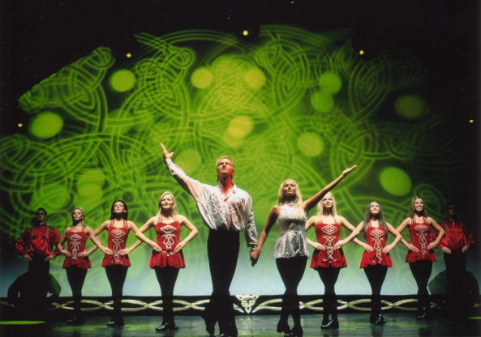

Compere I: Our show has come to its end. We think you’ve enjoyed it very much. Thank you for your attention! Good-bye!
Quotations :
1) The dance is a way to express all our secret feelings in an elegant and beautiful form. And if in the world there is a language barrier, the language of dance is universal and understandable to all.

Танец - это средство, помогающее выразить все наши потайные чувства в элегантной и красивой форме. И если во всем мире существует языковой барьер, то язык танца - универсален и понятен всем.
2) The dance is your pulse, your heartbeat, your breath. This is the rhythm of your life. It's the expression of time and movement, of happiness, joy, sadness and envy. (Jacques d’ Amboise)
Танец — это твой пульс, биение твоего сердца, твое дыхание. Это ритм твоей жизни. Это выражение во времени и движении, в счастье, радости, грусти и зависти. (Жак д'Амбуаз)

3) I'm dancing because I am happy. I'm dancing because I’m free. (Tosha Brown)

Я танцую — потому что я счастлива. Я танцую — потому что свободна. (Тоша Браун)
4) Dance is the highest mind in a free body. (Isadora Duncan)
Танец-высший разум в свободнейшем из тел. (Айседора Дункан)

5) There are moments of happiness...dance is one of them...

Существуют моменты счастья…танец один из них…

