Кіровоградський обласний

навчально-виховний комплекс

(гімназія-інтернат-школа мистецтв)

Англійська мова
6 клас

Конспект уроку на тему:
«Подоpoж до Лондону»

Вчитель
англійської мови:
Семеняченко Т.Т.
Дата проведення:
22.03.2013 р.

Кіровоград
Theme: “A Trip to London”
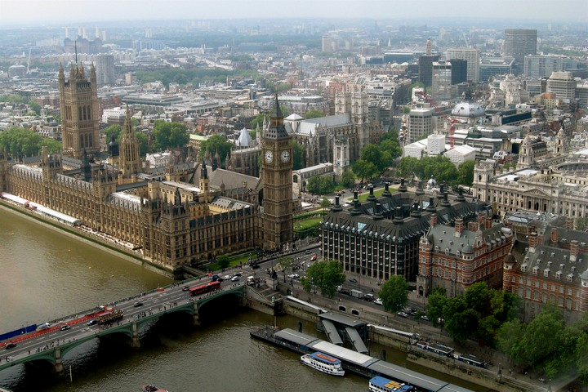 Objectives:
- to develop speaking skills;
- to improve listening comprehension;
- to involve the pupils into communication according to the given situation;
- to develop logical thinking;
- to foster positive emotions;
- to enlarge the knowledge of London and its places of interest;

Equipment: a map of Great Britain, sights of London, cards with tasks, a recorded song “Yesterday”, PowerPoint presentation “A Trip to London”.
Procedure of the lesson:
I. The beginning of the lesson
T: Good morning, children! Glad to see you. How are you today?
The theme of our lesson is “A Trip to London”. Today we’ll go on an imaginary trip to London, the capital of Great Britain. We’ll see and discuss the film about London and its places of interest. Then you’ll guide a tour about London, dramatize a dialogue, participate in a quiz, sing a song and, of course, enjoy the time of our communication and learning.
So, let’s start.

II. Phonetic Drill
T: Look at the blackboard, listen to me and read the poem after me. Be ready yo answer the questions.

London Places
Westminster Abbey, Whitehall and Fleet,
Trafalgar Square and Downing Street.
These places you visit in London, for sure,
And it will be an interesting tour!
Parliament Square, Westminster Bridge,
Oh, London’s history is so rich!
Famous Big Ben, mysterious Tower
Here you spend more than an hour!
London is full of places to visit
If you have chance, try not to miss it!
T: Is London full of places to visit? What London places are mentioned in this poem?

III. Warming Up
T: There is hardly any person who doesn’t like to travel. Do you agree with me? Why do people travel?
P1: It’s exciting.
P2: It brings us a lot of joy.
P3: We have lots of impressions.
P4: It broadens our knowledge.
P5: While travelling we learn many interesting things about different countries and their people.

IV. Main Part.
1. A Talk about London:
T: I know that all of you would like to visit London and see its places of interest. I hope that in the future your dream will come true. But today we’ll go on an imaginary trip to London. At first let’s see what you know about London.
P1: London is situated in Great Britain.
P2: It stands on the river Thames.
P3: The original name of London was Londinium.
P4: It’s the capital of Great Britain.
P5: It’s one of the largest cities in the world.
P6: It’s very old and it has many historical places of interest.
P7: It’s very popular among tourists.

2. Watching and Discussing the Film about London.
T: Let’s start our trip to London. They say that “It’s better to see once, than to hear a hundred times”. That’s why now you will have a chance to visit London and see everything with your own eyes. How? ... You’ll see the film about London. While watching it be very attentive and try to remember as much information as possible. Your task will be to name all the places of interest which are shown in the film.
But at first let’s see how you remember the names of London’s sights.
(Pupils are given cards with a task.)
Task: Match the parts and give the names of London’s sights:
Big (Ben)  Trafalgar (Square)  Bloody (Tower)  White (Tower)  Tower (Bridge)  Buckingham (Palace)  Westminster (Abbey)  The Houses of (Parliament)  The Tower of (London)  Hyde (Park)  (Pupils give the names of the sights.)  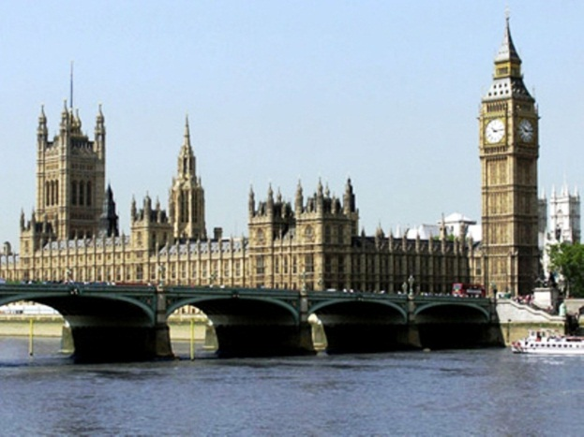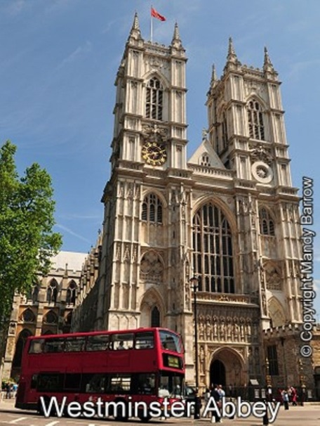  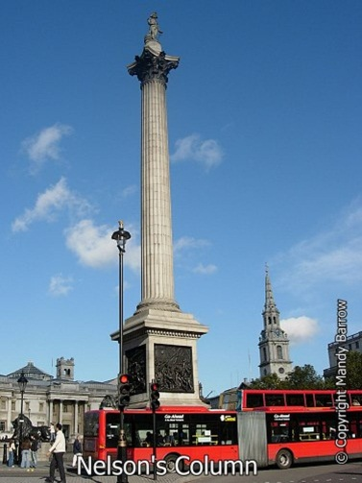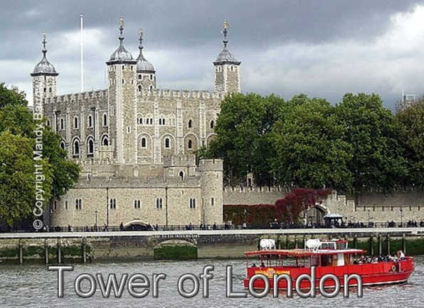  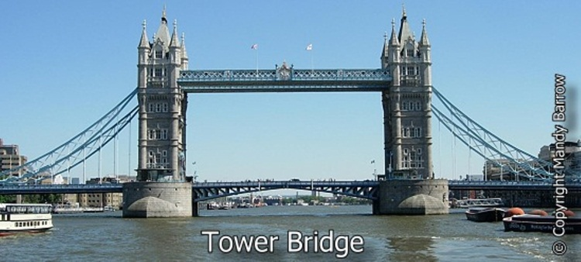  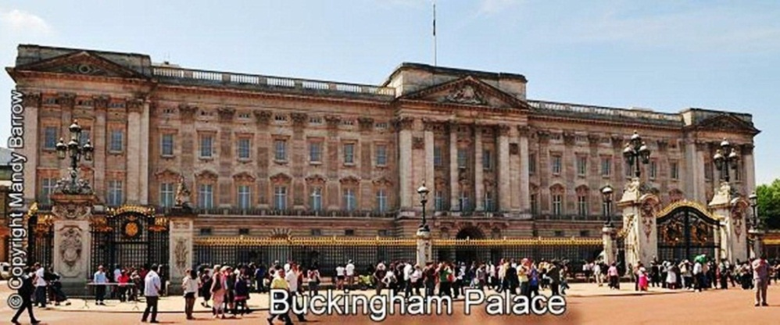  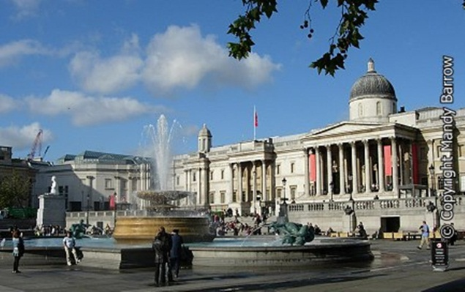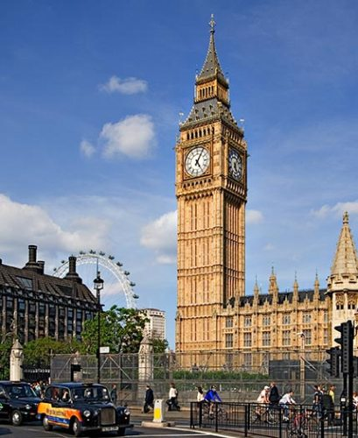  T: Well done! And now let’s see the film.  (Pupils see the film.)  T: Do you like the film? Why? What new things have you learnt from the film? What places of interest are shown in the film?  P₁: Big Ben  P₂: Trafalgar Square  P₃: The Tower of London  P₄: Westminster Abbey  P₅: …  P₆: … |  | Palace  Tower  London  Bridge  Ben  Square  Abbey  Tower  Park  Parliament
3. Monologue speaking “A Tour about London”
T: Imagine that we have just arrived in London and now we’re going to have a tour about the city. Our guides will tell us about its places of interest. Let’s start! Who wants to be our guides? … You are welcome!

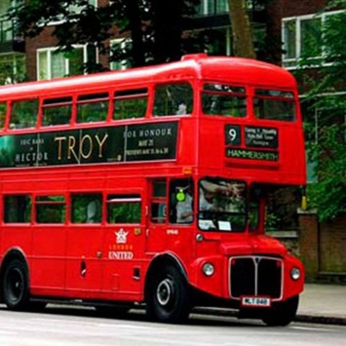 Red Double-Decker
P₁: Hello, dear friends! Welcome to London! London has many places of interest and today you’ll see these places and much more of London from our red double-decker.
We start from the City, which is the heart of London its financial and business centre. Many banks, offices, and firms are situated here, including the Bank of England. Few people live here, but over a million people come to the City to work.
P_{2:} There are some famous ancient buildings in the City. Perhaps the most striking of them is St. Paul's Cathedral, the greatest of English churches. It was built in the 17th century by Sir Christopher Wren. The other is the Tower of London which was founded by Julius Caesar and in 1066 rebuilt by William the Conqueror. It was used as a fortress, a royal palace, and a prison. Now it is a museum. Twelve black ravens live there. Each has got its name and the keepers carefully look after them because as one of the old English legends says: “London can be the capital of the country, rich and great, until twelve black ravens live in the Tower of London”.

P₃: Now we are in Westminster which is an official and aristocratic part of London. Buckingham Palace, the official residence of the Queen and Westminster Abbey, a royal church are situated here. Nearly all English kings and queens were crowned in Westminster Abbey. Many outstanding people were buried here, among them: Newton, Darwin, Chaucer, Dickens, Tennyson, Kipling and others.
Across the road from Westminster Abbey is Westminster Palace (the Houses of Parliament), the seat of the British Parliament. Here we can see the Clock Tower which is famous for its big bell known as "Big Ben".

P₄: Now we are in the West End, the richest and most beautiful part of London. It is the symbol of wealth and luxury. The best hotels, shops, restaurants, clubs, and theatres are situated there.
Here you can see Trafalgar Square the geographical centre of London. It was named in memory of Admiral Nelson's victory in the battle of Trafalgar in 1805. The tall Nelson's Column stands in the middle of the square.
On the north side of the Trafalgar Square you can see the National Gallery which has an outstanding collection of paintings from Britain, Italy, Denmark and other European countries. Not far away is the British Museum — the biggest museum in London. It contains a priceless collection of ancient manuscripts, coins, sculptures and is also famous for its library.

P_{1:} Our tour has come to its end. Thank you for your attention. Good-bye!

T.: Thank you, guides, for your stories about London and its places of interest.

4. Making up a dialogue: “Meeting in London”
T.: And now, children, imagine that being in London you’ve met one of your friends. Read the dialogue and then make up your own dialogues.

P₁: Hello, Ann! What a surprise to meet you here in London!
P₂: Hi, Mary! Fancy meeting you here. This place is fantastic!
P₁: Yes, it is! How long have you been here?
P₂: Oh, I arrived last Sunday.
P₁: Which places have you already visited?
P₂: Well, I’ve already visited Westminster Abbey, St. Paul’s Cathedral, the Tower of London, the Houses of Parliament …
P1: Oh, you have seen so many places! But which of them do you like best of all?
P2: Well, I like all of them, but I was greatly impressed by the Houses of Parliament with Big Ben on one of the towers. The buildings are magnificent! And the clock is so huge!
P1: I see you don’t waste your time. What about going somewhere to have a bite?
P2: Oh, it’s a good idea! Let’s go!
5. Quiz: “Who Knows London Better?”
T: Thank you for your dialogues. So, we have learnt a lot of things about London and its sights and now we’ll see who knows London better. I’ll ask you questions and you’ll get a point for each right answer. Are you ready? Let’s start.
1. What is London?
2. What's the population of London?
3. What parts is London traditionally divided into?
4. What is the City?
5. Who was the St. Paul's Cathedral built by?
6. Who founded the Tower of London? When was it rebuilt?
7. What is the official part of London?
8. What is the official name of the Houses of Parliament?
9. What is Big Ben?
10. What is in the middle of Trafalgar Square?
11. What is the most famous London museum?
12. What are the symbols of London?
13. What is the Queen’s name?
14. Who lives in the Tower of London?
15. What is “a red double-decker”?

T: Who’s got more points? … You are the winner! Our best congratulations!
V. Singing a song:
T: And now let’s relax a little bit and sing one of the most popular songs “Yesterday”.
(Pupils sing a song.)
Yesterday
Yesterday,
All my troubles seemed so far away
Now it looks as though they're here to stay
Oh, I believe in yesterday
Suddenly,
I'm not half the man I used to be
There's a shadow hanging over me
Oh, yesterday came suddenly
Why she had to go I don't know,
She wouldn't say
I said something wrong,
Now I long for yesterday
Yesterday,
Love was such an easy game to play
Now I need a place to hide away
Oh, I believe in yesterday
Why she had to go I don't know,
She wouldn't say
I said something wrong,
Now I long for yesterday
Yesterday,
Love was such an easy game to play
Now I need a place to hide away
Oh, I believe in yesterday

T: Do you like the song? What do you know about The Beatles?

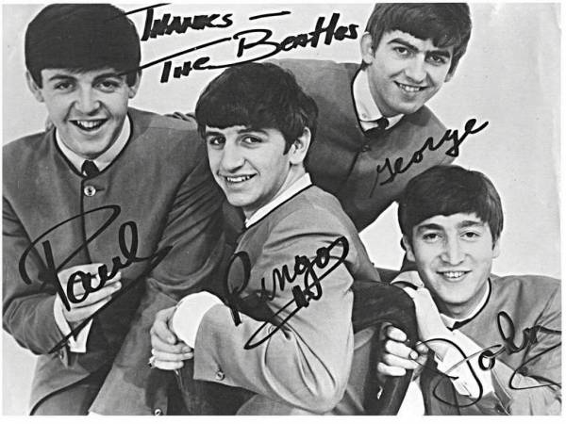

P: “The Beatles” is a legendary English rock band which was formed in Liverpool in 1960. The band consisted of John Lennon, Paul McCartney, George Harrison and Ringo Starr. The group worked in different genres, ranging from folk rock to psychedelic pop. They achieved natural popularity and success in late 1962 with their first single which was called "Love Me Do".

VI. The End of the Lesson
T: Our lesson has come to the end. Thank you for your good work today! Your marks are …. Your homework is to write a letter to your friend about your trip to London.

